 | MATHEMATICS:SPECIALIST 3 & 4  SEMESTER 2 2017  TEST 4  Calculator Free
Reading Time: 2 minutes Time Allowed: 25 minutes
Total Marks: 22

Question 1 (7 marks)
A region is bounded by the y-axis and the curves and as shown below.

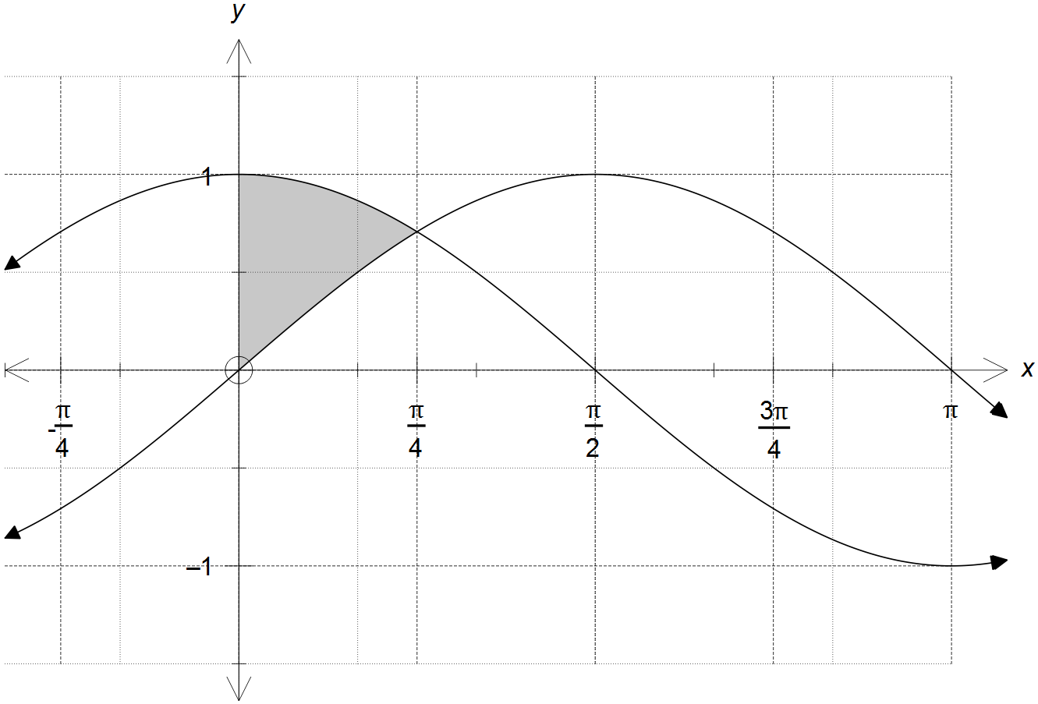

(a) Evaluate: (2 marks)
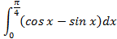

(b) Calculate the exact volume of the solid generated by rotating the region shown in the
diagram around the x-axis.
(5 marks)

Question 2 (15 marks)
Determine the following integrals.
(a) 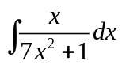 (2 marks)

(b)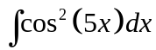 (3 marks)

Determine the following integrals with the given substitution.

(c)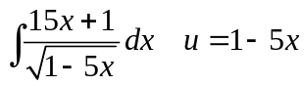 (3 marks)

(d)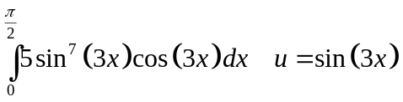 (3 marks)

Using partial fractions, or otherwise, determine

(e) . (4 marks)

MATHEMATICS:SPECIALIST 3 & 4
SEMESTER 2 2017
TEST 4
Calculator Assumed
Reading Time: 2 minutes Time Allowed: 30 minutes
Total Marks: 28

Question 3 (12 marks)
A small body is projected upwards from the top of a hill with an initial velocity of 32 ms⁻¹ at an angle of 60° to the horizontal. The hill slopes downwards at a constant angle of 30° to the horizontal. Let the origin of a cartesian coordinate system be the top of the hill, with a unit vector in the positive direction and a unit vector in the positive direction. Displacement is measured in metres and time in seconds.

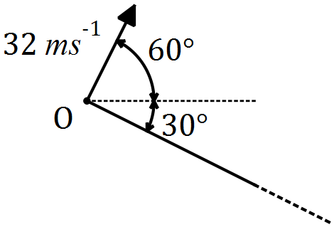

(a) Show that the initial velocity of the body is . (1 mark)

The acceleration of the body, seconds after projection, is given by .

(b) Determine an expression for the position vector of the body after seconds. (3 marks)

(c) Determine the time at which the body lands on the hillside. (3 marks)

(d) Calculate the distance of the body from at the instant it lands. (2 marks)

(e) Determine the maximum vertical height attained by the particle above the hillside.
(3 marks)

Question 4 (8 marks)
A particle moves in the Cartesian plane and the position vector of the particle at any time in seconds is given by the equation:

for

(a) Determine the speed of the particle when it first crosses the y-axis. (4 marks)

(b) Show that the particle moves with a constant magnitude of acceleration. (2 marks)

(c) Determine the Cartesian equation of the path traced by the particle and describe
its properties. (2 marks)

Question 5 (8 marks)
(a) Sketch the graph of on the axes below. (2 marks)

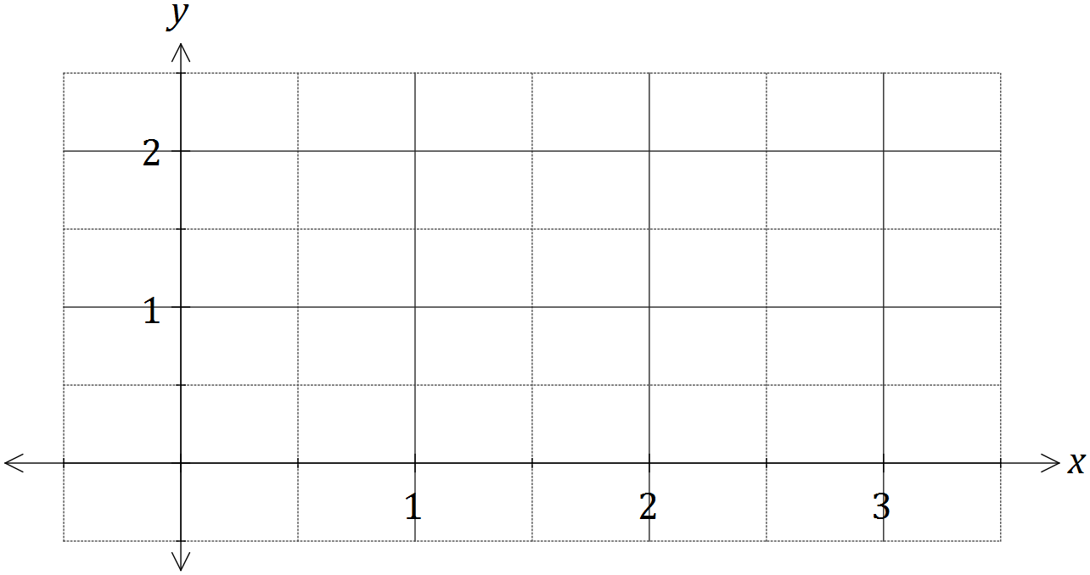
Simpson's rule is a formula used for numerical integration, the numerical approximation of definite integrals. When an interval is divided into an even number, , of smaller intervals of equal width , the bounds of these smaller intervals are denoted . Simpson's rule can be expressed as follows:
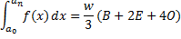
where , is the sum of the values of where is even and is the sum of the values of where is odd.

(b) Use Simpson's rule with to evaluate an approximation for , correct to four decimal places. (4 marks)

(c) Determine the exact value of and hence calculate the percentage error of the approximation from (b). (2 marks)

